Report on Summer Training

CREDIT APPRAISAL
AND DELINQUENCY LEVEL
ANALYSIS OF MMFSL
In partial fulfillment of the
Requirements for the award of Degree of
Master of Business Administration
Batch 2013 - 2015

Supervised by: Submitted by:
Mr. Clodious Priya
Assistant Professor Roll No. 123

ACKNOWLEDGEMENT
This project has been made possible through the direct and indirect cooperation of various persons for whom I wish to express my appreciation and gratitude.
I am especially thankful to my industry guide Mr. ABC, Manager, Mahindra & Mahindra financial services limited for his valuable and enlightened guidance. I am highly grateful to him for providing me an opportunity to undergo the project in his presence. Despite his hectic schedule he showed a keen interest in my research and helped a lot in broadening my vision for the topic.
I am also grateful to my faculty mentor Mr. Cloudious, Faculty Member, ABC Business School for his guidance and kind support throughout the project.
I would like to thank Mr. Aryan for providing me all the required help to compile the data and other information to materialize the study.

Priya

Table of contents
Chapter Number | Name of the Chapter | Page Number
Executive Summary |  | 4
1 | Theoretical Foundation | 6
 | 1.Introduction to industry | 7
 | 1.1 Types of NBFC’s | 7
 | 1.2 Importance of NBFC’s | 8
 | 1.3 Major players | 8
 | 2. Company profile | 10
 | 2.1 About Mahindra group | 10
 | 2.2 About MMFSL | 11
 | 2.3 Vision | 12
 | 2.4 Leadership @ Mahindra | 12
 | 2.5 Subsidiaries of MMFSL | 18
 | 2.6 History and milestones | 20
 | 2.7 Product and services | 22
 | 3. Literature review | 25
2 | Objectives of the study and Research Methodology | 27
 | 4. Objective of the study | 28
 | 5. Research Methodology | 28
 | 5.1 Present study | 28
 | 5.2 Scope of study | 28
 | 5.3 Data collection | 28
3 | Data presentation, analysis and interpretation | 29
 | 6. Credit Appraisal | 30
 | 6.1 Meaning | 30
 | 6.2 What are we appraising? | 30
 | 6.3 Credit appraisal process | 31
 | 6.3.1 Aspects of Credit appraisal | 31
 | 6.3.2 Factors affecting Finance amount & IRR | 35
 | 6.3.3 Financial tools for Credit appraisal | 36
 | 6.3.4 Case study analysis | 41
 | 7. Delinquency level analysis | 53
 | 7.1 Definition | 53
 | 7.2 Trend analysis | 54
 | 7.3 Sector wise delinquency level | 56
 | 7.4 Customer profile wise delinquency level | 57
 | 7.5 Dealer wise delinquency level | 58
 | 7.6 Reasons of default | 61
 | 7.7 Factors affecting delinquency level | 62
 | 7.8 Hypothesis | 64
 | 7.9 Research design | 64
 | 7.10 Data analysis | 70
4 | Conclusion and Recommendations | 79
 | 8.1 Finding and conclusion | 80
 | 8.2 Recommendations | 80

Executive summary
Indian economy is going through a period of rapid `financial liberalization'. The segment consisting of Non-Banking Financial Companies (NBFCs) have made great strides in recent years and are meeting the diverse financial needs of the economy. And Mahindra and Mahindra financial services limited (MMFSL) is India’s one of leading NBFC whose expertise lies in the rural and semi-urban sector of the country. MMFSL provides a financial services of vehicle finance including utility vehicles, commercial vehicles, cars and construction equipment finance, refinance, personal loans.
The goal of MMFSL is to upgrade the level of people who are at the bottom of social pyramid of the country by providing them financial help.
In the project entitled ‘Credit Appraisal and Delinquency Level Analyses of MMFSL-Ludhiana branch’ , an attempt has been made to study the Credit Appraisal process of MMFSL and to study the sector wise , dealer wise , and customer profile wise delinquency level of Ludhiana branch and also to find out the reasons and factor affecting delinquency level.
The scope of the study for the credit appraisal analysis and for the sector wise and dealer wise study of delinquency level was limited to the Ludhiana branch data only and for finding out the customer wise delinquency level and factors affecting delinquency level, the sampling frame comprising of 150 cases out of the total cases of Ludhiana branch was taken.
The process of credit appraisal of MMFSL was studied and with the help of some financial tools, the credit appraisal of few of the cases was also done to know the creditworthiness of the customer.
The delinquency level of Ludhiana branch has shown a decreasing trend, but still in few of the sectors, careful steps needs to be taken to decrease the OD days. There are different reasons which led to the increase in the default rate of the company like poor credit appraisal, intentional and situational defaults and many more. And also there are different factors like financial, operational and situational factors which affect the repaying habits of the customers like mode of payment, and the marital status.
The researcher found that credit appraisal process of MMFSL suffers from few limitations which lead to the increase in the delinquency level of the branch, so the recommended steps should be taken by the company so that the delinquency level can be reduced and the profitability of the organisation can be enjoyed.

CHAPTER – 1
THEORETICAL FOUNDATION

1. INTRODUCTION TO INDUSTRY
A Non-Banking Financial Company (NBFC) is a company registered under the Companies Act, 1956 and is engaged in the business of loans and advances, acquisition of shares/stock/bonds/debentures/securities issued by Government or local authority or other securities of like marketable nature, leasing, hire-purchase, insurance business, chit business but does not include any institution whose principal business is that of agriculture activity, industrial activity, sale/purchase/construction of immovable property. A non-banking institution which is a company and which has its principal business of receiving deposits under any scheme or arrangement or any other manner, or lending in any manner is also a non-banking financial company (Residuary non-banking company).

NBFCs are doing functions akin to that of banks; however there are a few differences:

- An NBFC cannot accept demand deposits;
- An NBFC is not a part of the payment and settlement system and as such an NBFC cannot issue cheques drawn on itself; and
- Deposit insurance facility of Deposit Insurance and Credit Guarantee Corporation is not available for NBFC depositors unlike in case of banks.

1.1 TYPES OF NBFC’S
Originally, NBFCs registered with RBI were classified as:
- Equipment leasing company;
- Hire-purchase company;
- Loan company;
- Investment Company.

However, with effect from December 6, 2006 the above NBFCs registered with RBI have been reclassified as
- Asset Finance Company (AFC)
- Investment Company (IC)
- Loan Company (LC).
Types of services that fall under the domain of non-banking finance services include the following;
- Investment Finance Services
- Investment Advisory Services
- Asset Management Services
- Venture Capital Services
- Leasing Services
- Housing Finance Services
- Discounting Services
- Any other form of business activities which the Federal Government may, by notification in the official gazette, specify from time to time
1.2 IMPORTANCE OF NBFC’S
According to RBI Non Banking Finance Companies (NBFCs) is a constituent of the institutional structure of the organized financial system in India. NBFCs perform a significant and important role in our financial system. They facilitate the process of channelizing of public savings and provide better return to the depositors. We are aware that due to liberalization and globalization, banking industry and financial sector has gone through many reforms. In the present economic environment it is very difficult to cater need of society by Banks alone so role of Non Banking Finance Companies and Micro Finance Companies become indispensable. The activities of non-banking financial companies (NBFCs) in India have undergone qualitative changes over the years through functional specialization. The role of NBFCs as effective financial intermediaries has been well recognized as they have inherent ability to take quicker decisions, assume greater risks, and customize their services and charges more according to the needs of the clients. While these features, as compared to the banks, have contributed to the proliferation of NBFCs, their flexible structures allow them to unbundle services provided by banks and market the components on a competitive basis. The distinction between banks and non-banks has been gradually getting blurred since both the segments of the financial system engage themselves in many similar types of activities. At present, NBFCs in India have become prominent in a wide range of activities like hire-purchase finance, equipment lease finance, loans, investments, etc. By employing innovative marketing strategies and devising tailor-made products, NBFCs have also been able to build up a clientele base among the depositors, mop up public savings and command large resources as reflected in the growth of their deposits from public, shareholders, directors and their companies, and borrowings by issue of non-convertible debentures, etc.
NBFCs have provided financial solutions to sections of society who hitherto were at the mercy of unorganized players for credit and savings product. NBFCs are once again in the spotlight for their perceived strengths and capabilities rather than their problems. While this re-rating ought to bring cheer to a much maligned sector, a degree of caution needs to be instilled within potential investors in NBFCs, who need to clearly understand the true drivers of value for finance companies. This understanding is imperative to enable a better judgment of the intrinsic worth of NBFCs.

1.3 Major players of NBFC’s
1) LIC Housing Finance
2) Reliance Capital
3) Shriram Transport Finance
4) IDFC
5) Mahindra and Mahindra financial services limited
6) GE money financial services
7) Muthoot finance
8) Manappuram finance
6) Magma Fincorp Limited
7) Cholamandalam investment and finance company limited
8) Sundaram finance group


2. COMPANY PROFILE
2.1 About Mahindra group
The US $6.7 billion Mahindra Group is among the top ten industrial houses in India and is the only Indian company among the top three tractor manufacturers in the world. The Mahindra group has, over the years, established a significant presence in all the crucial sectors of the Indian economy. Consistently setting new standards, it is now considered to be one of the key performers of the country.
The company was originally set up in 1945 as Mahindra & Mohammed. Later, after the partition of India, Ghulam Mohammad returned to Pakistan and became the nation's first finance minister. Hence the name was changed from Mahindra & Mohammed to Mahindra & Mahindra in 1948.
While retaining its core values of introducing rural India to technological advancements, the company has steadily transformed itself into a group that caters to the Indian and overseas markets with a presence in various business sectors: Automotive, Farm Equipment, Financial Services, Systech, After-Market, Information Technology, Specialty Business, Infrastructure Development, Trade, Retail and Logistics.
Steered by Chairman Keshub Mahindra and Managing Director Anand Mahindra, Mahindra & Mahindra has constantly grown in size and stature and evolved into a group that occupies premier position in almost all the sectors in which they operate. Making state-of-the-art technology an accessible and affordable commodity is what takes the company from strength to strength with every passing year.
With over 62 years of manufacturing experience, the Mahindra Group has built a strong base in technology, engineering, marketing and distribution which are vital to its evolution as a customer-centric organisation. The group employs over 75,000 people and has several state-of-the-art facilities in India and overseas.

2.2 About MMFSL
Mahindra and Mahindra Financial Services Limited is one of India’s leading non-banking finance companies. Through a vast network of branches, they provide personalized finance for the widest range of utility vehicles, tractors and cars, focusing on the rural and semi-urban sector.
MMFSL’s rural financing is considered as the cornerstone of poverty reduction, rural development and inclusive growth in many parts of the country. With a majority of our country’s population living in rural India, our loans to over 10,00,000 customers belonging to the low income groups have proved to be a catalyst in helping rural India surge ahead in a big way.
Their unique business model is socially inclusive as they help customers who are at the bottom of the income or social pyramids to grow by providing them loans based on their future earning capacities. It is also their continuous endeavor to develop skill sets at the local level. They currently provide employment to over 6200 people who belong to the areas in which they serve, ensuring that their employees truly understand their customers.
Since 1945, people, at the Mahindra Group, have remained and will continue to remain partners in the progress of rural India, through both growth and turbulence. They salute the spirit of every Indian living off the land and move ahead, trying to understand the financial needs of rural India and tapping into this vast market of unbounded opportunities.
Their goal is to be the preferred provider of retail financing services in the rural and semi-urban areas of India, while their strategy is to provide a range of financial products and services to the customers through our nationwide distribution network.

2.3 Vision





2.4 Leadership @ Mahindra
At Mahindra Finance, they have leaders vested with the charge of general supervision, direction and management of the operations of our company.
The primary responsibility of the Board of Directors includes:
- Overseeing high standards of corporate governance and compliance with various laws
- Overseeing our financial management and approving various lines of business
- Shaping our policies and procedures
- Monitoring our performance and evolving the growth strategy
- Setting up counter-party and other prudential risk management limits
(1)
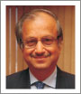 Mr. Bharat N. Doshi, (Chairman)
Mr. Bharat Doshi is a fellow member of both, the Institute of Chartered Accountants of India and the Institute of Company Secretaries of India and has a Master’s Degree in Law from the University of Bombay. He has participated in the Program for Management Development at the Harvard Business School.
Mr. Bharat joined Mahindra & Mahindra Limited (M&M) in the year 1973. He is presently designated as Executive Director and Group Chief Financial Officer (Group CFO), M&M. Mr. Bharat Doshi is very actively involved with the work of several Chambers of Commerce and Industry in India and is a member of various Expert Committees, which influence economic and business policies of the Government. He was a member of the High Powered Expert Committee constituted by the Ministry of Finance, Government of India, on Making Mumbai an International Financial Centre and is a member of the SEBI (Securities and Exchange Board of India) Committee on Disclosures and Accounting Standards (SCODA).
Mr. Bharat Doshi was the Chairman of Expert Committee on Economic Affairs of Bombay Chamber of Commerce and Industry (BCCI) during 1996-97. He was a member of the Managing Committee of Bombay Chamber of Commerce & Industry from May 2005 to May 2007. Mr. Bharat Doshi has been elected as Vice President of Bombay Chamber of Commerce & Industry (BCCI) for the year 2008-09.
Mr. Bharat Doshi was adjudged ‘India’s Best CFO’ by the leading business fortnightly ‘Business Today’ (India Today Group Publication) in April 2005. He was also conferred the 'CFO of the Year' Award, honouring financial excellence, instituted by IMA India, an associate of The Economist Group, in December 2005. In November 2007, Bharat Doshi was honoured with the prestigious CNBC CFO of the Year 2007 award.
(2)
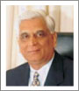 Mr. U. Y. Phadke, (Vice-Chairman)

Mr. U. Y. Phadke is a member of the Institute of Chartered Accountants of India and the Institute of Company Secretaries of India and has a Bachelor's degree in Commerce and Law.
Mr. Phadke joined Mahindra & Mahindra in 1973. He is presently designated as President - Finance, Legal and Financial Services Sector and Member of Group Management Board.
Mr. Phadke is the Vice-Chairman of Mahindra & Mahindra Financial Services Limited. Mr. Phadke has been Chairman of the Direct Taxes Committee of the Bombay Chamber of Commerce and Industry and on the Accounting Standards of Board of the Institute of Chartered Accountants of India. He is a Member on the `National Committee on Professional Services' of CII & he is on the Governing Council of Indian Association of Corporate CFOs and Treasurers. He is a Member of the Working Group on ‘Employee Benefits’ constituted by the International Accounting Standards Board. He is also a Special Invitee to the meetings of National Advisory Committee on Accounting Standards constituted under the Companies Act.

(3)
 Mr. Ramesh Iyer, (Managing Director)
Mr. Ramesh Iyer has been the Managing Director of the Company since 2001 and is associated with the Company since its inception. Mr. Iyer, a commerce graduate and an MBA from Mumbai University was working with Ashok Leyland Finance Limited prior to joining the Company. He is also a member of core committee of Finance Industry Development Council. Mr. Ramesh Iyer has been awarded with the Udyog Rattan from The Institute of Economic Studies, New Delhi and has also been presented with ‘Rashtriya Udyog Pratibha Award’ from the Council for Economic Growth & Research, Pune in December, 2007. Presently he is the Chairman of Banking & Finance Committee of Bombay Chamber of Commerce & Industry.
(4)
 Mr. Dhananjay Mungale, (Director)
Mr. Dhananjay Mungale is a Chartered Accountant and a Law graduate. He has spent a major part of his career in corporate and investment banking in India and Europe with Bank of America and DSP Merrill Lynch Ltd. He is presently acting as advisor to various corporations in India and Europe. He is on the Board of various public and private limited companies.

(5)
 Dr. Pawan Kumar Goenka, (Director)
Dr. Pawan Kumar Goenka is a Mechanical Engineer with a B. Tech from the Indian Institute of Technology, Kanpur, and a Ph.D. from Cornell University, USA. He has also done an Advanced Management Programme (AMP) at the Harvard Business School.
Dr. Pawan Goenka joined the Mahindra Group in October 1993 as General Manager – Research & Development, after a successful career spanning 14 years with General Motors, USA. Under his leadership, Mahindra & Mahindra launched a slew of new products such as Pick-Up, Marshal, Armada 98, Bolero and Loadking. His best acknowledged contribution is his leadership of the Scorpio project, which brought laurels to Mahindra & Mahindra, both in India and abroad. He became Executive Vice President – Product Development in September 2001, and was promoted to Chief Operating Officer of the Automotive Sector in April 2003. Dr. Goenka took over as President of the Automotive Sector on 26th September 2005. Among other achievements, he has also played a key role in the formation of both the Renault and International Truck joint ventures.
Dr. Goenka is an internationally acknowledged scientist – manager with several citations to his credit. He received the Distinguished Alumni Award from the Indian Institute of Technology, Kanpur in 2004 and is a Fellow of the Society of Automotive Engineers (SAE) and of the Indian National Academy of Engineers. He has been honored by General Motors through the Charles L McCuen Achievement Award twice and the Extraordinary Accomplishment Award. Dr. Goenka is the Vice President of SIAM Executive Council and Chairman of the Technical Committee. He holds the position of President of the ARAI Governing Council and is a past-President of SAE India.

(6)
 Mr. M. G. Bhide, (Director)
Mr. M. G. Bhide is a M.A., CAIIB. He was the Chairman & Managing Director of Bank of India. He was also the Managing Director & Group Executive (National Banking) of State Bank of India. He has also served on various Committees constituted by the Reserve Bank of India.
(7)
 Mr. Piyush Mankad, (Director)
Mr. Piyush Mankad did his post graduation in History from St. Stephen’s College, University of Delhi, and obtained a post graduation diploma in Development Studies with Distinction from Cambridge, U. K.
Mr. Mankad is a retired civil servant. He was the Managing Director, State Industrial Development and Investment Corporation and ex-officio Secretary to the State Government. He has also held important positions including those of Counsellor Economic, Embassy of India – Tokyo, Controller of Capital Issues – Ministry of Finance, Director General – National Productivity Council of India, Secretary – Departments of Industrial Development and Public Enterprises, Secretary – Industrial Policy and Planning, Chairman – Foreign Investment Promotion Board, Secretary Information and Broadcasting, Finance Secretary – Government of India and Executive Director (India) and Board Member – Asian Development Bank, Manila. He was also a member of Telecom Commission, Space Commission and Atomic Energy Commission and is on the Board of IIM Ahmedabad, IIM Calcutta and IIM Bangalore. He was a Member of the Investment Advisory Committee of the Army Group Insurance Fund, India. He also served on the Asia Pacific Advisory Committee of Barclays Capital U.K. He is a Trustee of the Vodafone India Foundation. He is also a Member of the Governing Body - Lady Shriram College for Women, New Delhi and Association of Indian Diplomats.
(8)
 Mrs. Rama Bijapurkar, (Director)
Ms. Rama Bijapurkar graduated with a B.Sc. (Hons.) degree in Physics from Miranda House, Delhi University and a Post Graduate Diploma in Management from Indian Institute of Management, Ahmedabad. She is an independent market strategy consultant and also a visiting faculty and member, Board of Governors of the Indian Institute of Management, Ahmedabad. She has over 30 years of experience in industries such as advertising, marketing and consultancy. She has previous work experience with McKinsey & Company, MARG (now AC Nielsen India), and been a full time consultant with Hindustan Unilever Ltd.
Mrs. Rama Bijapurkar has published extensively on emerging market and consumer related issues and is the author of the book titled “Winning in the Indian Market – Understanding the Transformation of Consumer India”. She serves as an Independent Director on the Boards of various reputed Companies.

2.5 Subsidiaries of MMFSL
(1)Mahindra Insurance Brokers Ltd
Mahindra Insurance Brokers Ltd. is one of the few insurance broking companies in India who have been awarded the prestigious ISO 9001:2008 Certification for Quality Management Systems MIBL’s aim is to play a predominant role in the insurance broking industry in India while focusing on providing innovative solutions, greater value to customers, superior quality of service and professional manpower keeping in mind the spirit of social responsibility.
Committed to maintaining a high standard of excellence, MIBL has empanelled itself with various public and private insurance companies to offer highly customised solutions to its customers. A determined, dynamic and highly competitive insurance broking company, MIBL’s core asset is the delivery of timely and cost-effective insurance solutions.
MIBL was granted a Direct Broker License by the Insurance Regulatory and Development Authority (IRDA) on May 2004 for undertaking direct insurance broking in Life and Non-Life businesses.
MIBL undertakes direct insurance broking business, both in the Life and Non-Life insurance segments with a focus on Retail and Commercial lines of businesses
(2) Mahindra Rural Housing Finance
Mahindra Rural Housing Finance provides cost-effective and flexible home loans to a wide base of customers in rural and semi-urban India. Providing loans for home construction, purchase, extension and improvement, MRFHL makes sure that its customers’ basic need of shelter is met for expediently. MRHFL tries to live up to its slogan ‘Ghar Ki Baat Hai’ by being highly customer centric while considering the customers as a part of its extended family.
MRHFL is responsible for the upgradation of many ‘Kuccha’ and infirm structures made of mud to ‘Pukka’ houses made of bricks and mortar. It has also provided funding for numerous rehabilitative efforts like changing the flooring of houses from rough cement base to tiles, etc. that have improved living conditions in many parts of Rural India.
A subsidiary of MMFSL, Mahindra Rural Housing Finance was incorporated on April 9, 2007 and obtained a certificate of registration to commence the business of a Housing Finance Institution from the National Housing Bank on August 13, 2007. MRHFL now operates in various locations throughout the country which include Gujarat, Maharashtra, Andhra Pradesh, Karnataka, Tamil Nadu and Kerala.
2.6 History and milestones
The history of Mahindra Finance has been a history of continuous ascent. Listed below are the important events and milestones in the story of Mahindra Finance.
Incorporated on January 1, 1991 as Maxi Motors Financial Services Limited and received certificate of commencement of business on February 19, 1991. Their name was changed to Mahindra & Mahindra Financial Services Limited on November 3, 1992. They are registered with the Reserve Bank of India as an NBFC. The Company is having a valid Certificate of Registration No. 13.00996 issued by the Reserve Bank of India under section 45-IA of the Reserve Bank of India Act, 1934 classifying it as an ‘Asset Finance Company – Deposit Taking’.
Milestones:
1993
- Commenced financing of Mahindra and Mahindra Utility Vehicles.
1995
- Opened their first branch outside Mumbai, at Jaipur.
1996
- Commenced financing M&M dealers for purchase of tractors.
1998
- Launched a pilot project for retail tractor financing.
1999
- Commenced tractor retail financing in rural and semi-urban areas
2001
- Total Assets crossed the 10 billion mark.
2002
- Commenced financing of non-Mahindra & Mahindra vehicles.
- Received Tier II debt from International Finance Corporation.
- Made our first securitisation transaction of Rs 438.8Million.
2004
- Opened a branch in Port Blair.
- Received a long-term credit rating of AA+/Stable.
- Commenced Insurance Broking through our subsidiary MIBL.
- Securitisation of tractor assets of Rs.256.6 million.
- Listing of non convertible debentures on BSE on the wholesale
debt market segment.
2005
- Tied up with HPCL Made Mahindra Insurance Brokers Ltd our wholly owned subsidiary.
2006
- Issued our IPO.
- Tied up with Maruti Udyog Limited.
2007
- Reach extended to over 400 branches.
2008
- Commenced the home loan business through our subsidiary, Mahindra Rural Housing Finance Limited (MRHFL)
2009
- Recommenced Fixed Deposit programme.
- Received 12.5% equity participation from NHB for our Subsidiary Mahindra Rural Housing Finance Ltd.
2010
- Loan against Gold launched in Kerala.
- Assets under Management crosses Rs. 10000 crores.
- PBT crosses Rs. 500 crores.
- Branch network crosses 450 branches.
- More than 2 lakh new customer contracts in a financial year for the first time.

2.7 Product and services

With an extensive range of products and services, Mahindra Finance, make sure that there’s something that suits everyone’s needs. Their products and services are considered instrumental in the rapid development of rural as well as semi-urban India.
Here’s a list of products and services offered by MMFSL:
- Utility Vehicles:
Their attractive schemes for multi-utility vehicles have helped many entrepreneurs to transform their dreams into reality. They provide finance for the entire range of Mahindra Utility Vehicles and also provide trade advance facilities for dealers.
- Tractor Loans:
With the majority of our country’s population engaged in farming and agriculture, their farm equipment loans have proven to be a major catalyst in helping rural India surge ahead. The widest range of tractors of the Mahindra, Swaraj & Shaktiman brands is financed by their highly customised loans.
- Car Loans:
They are the preferred financier for M&M as well as all other small car manufactures in the country— Hindustan Motors, Hyundai, General Motors, Maruti Udyog Limited. The loan obtaining process ensures maximum flexibility, minimum paperwork and highly customised loans to suit our customers’ needs.
- Two-Wheeler Loans:
For a wide range of two-wheelers which include motorbikes, mopeds, scooters or scooterettes, they make sure that their customers are offered speedy loans with flexible repayment options. They also provide loans to women customers at special rates and offer fast approvals for the same.
- Three-Wheeler Loans:
Their customised financial options and quick process of sanctioning a loan makes acquiring a new three-wheeler easier than ever before. A wide range of Mahindra three-wheelers are financed with flexible repayment options and minimal documentation.
- Refinance:
They provide fast and easy financial options to purchase used cars, utility vehicles, commercial vehicles and tractors. They also provide expedient loans against an existing car, utility vehicle and other commercial vehicles.
- Commercial Vehicle Loans:
At Mahindra Finance, they also provide commercial vehicles and construction equipment loans. Commercial vehicles include trucks, buses, tippers, excavators, light commercial vehicles and more. They fund new vehicles as well as old ones and even top-up existing loans.
- Construction Equipments:
Customers in need of construction equipments can avail of their range of flexible loans, and simple loan process. They also extend financial assistance for buying second hand commercial vehicles.
- Home Loans:
Mahindra Rural Housing Finance, a subsidiary of MMFSL, provides cost effective and flexible home loans to a wide base of customers and semi-urban India. Loans are provided for home construction, purchase, extension and improvement.
- Investment Advisory Services - Mutual Fund Distribution

Their investment advisory services help customers invest their money in equity through different Mutual Fund Schemes. They assure our client’s high returns by identifying products compatible with their appetite for risk and best suited for their needs.
- Personal Loans:
Now customers will never have to worry about that extra amount needed to fulfill all their needs. Be it Marriage related expenses, Children’s higher education, Medical treatment, Agricultural needs or just a temporary requirement of money.
- Insurance:
Mahindra Insurance Brokers Ltd., a subsidiary of MMFSL, provides comprehensive Insurance solutions that are highly customised to give you the most suitable options that fit your requirements. MIBL undertakes direct insurance broking business, both in the Life and Non-Life insurance segments with a focus on Retail and Commercial lines of businesses.

3. LITERATURE REVIEW
Treacy and Carey (2000) suggest that in designing a credit rating system, the lender should consider numerous factors, including cost, efficiency of information gathering, consistency of rating produced, staff incentives, and nature of a financer’s business and uses to be made of the internal ratings.
Crouhy etal (2001) suggests that banks should analyze three different categories of variables- quantitative, qualitative and legal. The quantitative analysis concentrates mainly on financial analysis. As for the qualitative analysis, the principal concern will be the quality of a borrower’s management. Finally, legal analysis refers to the authority and capacity to borrower.
Mathew Joseph ( Senior General Manager) HDFC, (Sep 2007) founds that appraisal process involves two major things: Identification and Assessment, where Identification involves Information Acquisition, Documentation, Customer Interface Techniques and Assessment involves Identifying key risks, Identifying Mitigating mechanisms, Integration , Collation of data along with information gathered at the personal interview.
Kamdica, Union Bank of India (2009) concluded that Credit Appraisal is done by thorough study of the project which involves: Evaluation of Management, Technical Feasibility, Financial Viability, Risk Analysis and it is on the basis of credit risk level that the collateral securities to be given by the borrower are determined.
Darshan Jindal, HDFC (banking business unit) (2010) found that banks have in place a well defined framework for approving credit limit of different segments. Request for credit facilities from the prospective borrowers shall be on the prescribed format and the full fledged proposal should be prepared for submission to the appropriate sanctioning authority for approval.
Sayan Chatterjee at ING Vysya Bank (2010) stated that credit department thoroughly analyses the credit requirement of the company and the capacity to service the debt. The bank has conservative norms to appraise the project. The bank at the maximum allows a 20% hike in projections.
N.Muthukumaran at ICICI bank ltd. (2010) conducted a survey on 5 banks to know about their credit appraisal system and the perspective of customer towards the credit appraisal process and their satisfaction level and concluded that direct interaction with the customer should be improved while doing the credit appraisal and loan processing should be reduced to 4-5 days, and documents required for processing the loan should also be reduced.

CHAPTER – 2
OBJECTIVES OF THE STUDY AND RESEARCH METHODOLOGY

4. Objective of study
- To know the process and criteria of credit appraisal in Mahindra & Mahindra financial services limited.
- To find out the sector wise, dealer wise, customer profile wise delinquency level of MMFSL- Ludhiana branch.
- To find out the reasons and factors affecting delinquency level.

5. Research methodology
5.1 Present study
The above mentioned and other similar studies made the plot for the present study.The author attempt to study the process and criteria of Credit Appraisal in MMFSL and refined study of delinquency level of Ludhiana branch to find out the reasons and factors affecting delinquency level. Convenient sampling was chosen and data was collected from 150 files and considered for Data Analysis.
5.2 Scope of study
For the Credit Appraisal analysis, the scope was limited to the cases of Ludhiana branch only.
For the Sector wise and Dealer wise study of Delinquency level, the scope was limited to the Ludhiana branch data only and for finding out the Customer Profile wise delinquency level and factors affecting delinquency level, the sampling frame comprising of 150 cases out of the total cases of Ludhiana branch was taken.
5.3 Data collection
The study was descriptive in nature and Secondary data was collected by considering the 150 files from the cases of Ludhiana branch only using convenient sampling.

CHAPTER -3
DATA PRESENTATION, ANALYSIS AND
INTERPRETATIONS

6. Credit Appraisal
6.1 Meaning:
The process by which the lender appraises the credit worthiness of the prospective borrower is known as credit appraisal. This normally involves appraising the borrower’s history and establishing the quality and sustainability of his income. The lender satisfies himself of the good intensions of the borrower, usually through an interview.
The assessment of the various risks that can impact on the repayment of loan is credit appraisal. In short, you are determining "Will I get my money back?" Depending on the purpose of loan and the quantum, the appraisal process may be simple or elaborate. A prospective borrower has to go through the various stages of the credit appraisal process of the financial institution. Each financial institution has its own criteria to satisfy itself on the credit worthiness of the borrower.

6.2 What are we appraising?
PERSON:
1) Capacity - The ability to service the loan by financial resources/ income streams.
2) Inclination -Willingness to pay.
PROPERTY:
1) To check documents for creation of security.
2) To ensure end use.

6.3 Credit Appraisal Process
Every financial institution has its own criteria and process of credit appraisal. The process of credit appraisal which is followed in Mahindra and Mahindra financial services limited is explained as below:
(A)Lead generation: Very firstly, the lead is generated by the sales executive which can be done in either of the following ways:
- through the dealership
- through walk in customer
- road shows
- advertisement
- own sources
After the generation of lead- the customer is informed about the different products, their features and different schemes and policies of the company and if the customer agrees to all the things then they initiate the investigation process.
(B)Investigation process: The second stage is the investigation process in which the necessary information about the applicant is acquired which is done in the following manner:
(a) Field Investigation (FI) - There is majorly two sources of FI i.e. through FI Agency and Inhouse FI.
Many of the companies take the help of FI Agencies to do the Field investigation but MMFSL and many other organizations do the Inhouse FI, where the sales executive of MMFSL itself goes for the FI and acquire all the information about the applicant. Sometimes, FI is also done by the credit manager when the loan amount is big. While doing the investigation, the sales executive tries to appraise the credit worthiness of the customer and also assesses the customer’s ability to meet his obligations.
6.3.1 The aspects which are considered while doing the credit appraisal of the borrower are as follows:
- KYC Norms: Very firstly, KYC norms are followed, whereby, the sales executive tries to know his customer and acquire the basic information about the borrower. Identity proof, Residence proof and Income proof are the main parameters of KYC norms considered here.
- Need of vehicle: The sales executive tries to find out the purpose of taking the vehicle and the finance by the customer.
- Capacity to pay: The lender also desires to know about the income source of the borrower and whether he will be able to repay the loan or not. And also wants to know about the income flow of the customer that whether it is monthly, half yearly or annually.
- Past loan record: The tracks of borrower’s previous loans are also traced, which can be done with the help of CIBIL or the statement of his transactions is traced from the financial institution from which he had taken the loan.
- Stability of his living: Stability of living of applicant is judged by considering the continuous number of years he is living in his owned house at the same place .It is also considered as the important part of customer’s worthiness.
- Reference check: The reference of individuals is also needed by the lender to reduce the risk of default in future .It can be taken from the three parties-1) neighbor, 2) colleague, 3) relatives.
The first two parties are considered as important.
In the case of Neighbor- The degree of closeness with the applicant is of paramount importance. He should not be living at a distant place from the applicant’s house.
In the case of Colleague-The referee can be a partner, colleague or senior to him, but he should not be at the lower level to him.
In case of Relative-It is considered as a week reference because it contains personal relationship with the applicant, which can be biased. So, it is not considered as an important reference.
- Guarantor: The guarantor should not be having any personal relation with the applicant. He should be a third party and moreover, the degree of his recommendation is also taken into consideration, that how strongly or weakly he recommends the applicant.
- How will he repay: The periodicity of the installment to be paid by the applicant also matters, whether the applicant will be paying the installment on monthly basis, or half yearly or on annual basis that also matters.
- Age of applicant: The age of the applicant also plays an important role. If the applicant is above the age of 50 years then the risk factor increases because then the probability of the applicant getting prone to health problems increases, so, in that case a medical certificate is asked from him, while it is not as such in case the applicant is young.
- Ability and intension: During field investigation, the ability and intension of the customer to repay the loan is checked. The customer, who has the ability i.e. he has a good source of income as well as a good intention to repay the loan, is considered as a good customer.
- Property of the customer: Ownership of some property in the name of the customer enhances his financial credibility. The customer who owns some property in his name has better chances of receiving the loan by the company.
- Family members’ credentials: The status of family members of the applicant also adds on to the credibility of the applicant. Their strong financial status makes the applicant a good customer.
- Bank statement: As a part of documentation, latest six month bank statement of the applicant and guarantor is taken which shows their banking transactions and average balance maintained in the bank. This helps in identifying a financially sound customer.
- ITR Statement: The Income Tax return statement shows the taxable income of the customer. A customer with good taxable income is considered reliable and eligible for loan.
- Qualifications: The educational qualification of customer also adds to his creditability, because a customer who is well qualified is considered as a good customer.
- Nature of profession: The profession under which the customer is indulged also matters, if he is indulged in some good and reputed profession then it will add up to his eligibility of loan.
- Experience: The experience of applicant in the industry also matters; it shows his stability and reliability.
- Employer: The Company where the applicant is working or the employer is also seen, because if his company has a good reputation in the market then it will add to his reliability and creditability and vice-versa.
- Assets owned and their financing patterns: Information related to the other assets owned by the customer and their financing pattern is also sought.
- Additional sources of income: If a customer has some other sources of income also, which will add to his financial soundness, and then it is also taken into consideration because it will reduce the risk factor of the case.
- Recurring liabilities: The details about the upcoming liabilities of customer also need to be known, so that the creditability of the customer can be judged rightly.
- Investments: If the customer has made some investment, then information related to that also needs to be sought .because if it is so, then he must be earning something out from that also, in the form of interest , which will add to his earning and financial strength.
- Other present and expected liabilities.
- Vehicle which is demanded by the client should match with his income ability and profession.

(b) CIBIL check-The second part of investigation is the CIBIL check of the applicant. CIBIL stands for credit information bureau (India) limited. It is India’s first credit information bureau. It is a repository of information, which contains the credit history of commercial and consumer borrowers. The data that CIBIL collects is used in creating credit information reports, also known as CIRs. These reports contain; basic borrower information (such as names, DOB's and addresses), past payment history, overdue amounts, records of all the credit facilities availed by the borrower, suit-filed status and number of inquiries made on that borrower, by different Members. It helps in identifying the repayment track records. It helps in protecting lenders from giving credit to people and establishments who are unlikely to repay what is lent. Even if credit is provided, it is done so at a very high rate of interest, thereby ensuring that the bank is able to recover a considerable sum of money even if a default happens some time into the loan tenure.
The norms differ from financer to financer. Each has certain norms within which a prospective borrower needs to fit to be eligible for the finance. Based on these parameters, the maximum amount eligible and the rate of interest is worked out. There are different factors which affects the decision related to the IRR of the company. These are as follows:
6.3.2 Factors affecting finance amount and IRR:
There are different factors which affect the decision of IRR, these factors are as follows:
- Company policies: The Company has set some policies for different segments of vehicle. The IRR is decided only after considering those policies.
- Competition: This is the main factor which influences the IRR decision of the case. If the competitors are charging less IRR then accordingly we also will have to decrease the IRR offered to get the lead and vice versa.
- Location: It is also one of the important factors which influence the IRR. The company will charge higher IRR in that area where there is less competition and they enjoy a kind of monopoly there, and lower IRR in the area where there is more competition.
- Tenure of loan: If the tenure of loan is high, then the IRR charged will also be high because in that case the risk factor increases. And if the tenure of loan is low, the IRR charged will also be low.
- Finance amount: If the finance amount is large then high IRR will be set because in that case, the risk increases and if finance amount is small then low IRR will be set.
- Asset: It is also one of the factors which influence their decision, like if the asset financed is a commercial vehicle then the IRR will be high, because in that case, the finance amount is large, so risk is also high and if it is a non-commercial vehicle, then the IRR will be set low.
- Financial strength of the customer: If the customer has a very sound financial status then we can charge high IRR from him because he has the ability to pay high ROI and there are less chances of him to negotiate on this.
- Customer base: The customer base of the company also influences the decision of fixing the IRR. As the major customer base of Mahindra and Mahindra financial services limited is the rural and semi urban people, so the company set their IRR keeping in mind their customer base. When the decision about the IRR is taken, at the same time the decision related to the funding amount is also taken. The lender decides the finance amount which should be granted to the borrower and IRR keeping in mind his financial soundness. There are different methods which are used to arrive at that decision. Some of them are discussed below:
6.3.3 Financial tools of credit appraisal
(1) FOIR – Fixed Obligation to Income Ratio
This stands for Fixed Obligation to Income Ratio. In FOIR calculation, the Financial institution takes into account the installments of all other loans previously availed of by the customer, including the home loan applied for. In other words, this ratio includes all the fixed obligations that the customer is supposed to pay regularly on a monthly basis. The Fixed Obligations however, do not include statutory deductions from the salary like Provident Fund, Professional Tax and deductions for investment like Voluntary Provident Fund, Insurance Premiums, Recurring deposits etc.
For example: Income -Rs 50,000 p.m.
Car loan installment: Rs 8,000 pm
Fridge loan installment: Rs 2,000 pm
Proposed housing loan installment: Rs 15,000 pm
Accordingly, the FOIR is 50 percent i.e. Rs 25,000. (All loan installments divided by the monthly income). The Financer may have a standard of 30 percent of FOIR. In this case, the total installments the person can pay as per the bank's FOIR standard would be Rs 15,000 per month. As the borrower is already paying Rs 10,000 pm for car and fridge, he has Rs 5,000 left and the loan would be calculated taking Rs 5,000 per month as the loan repayment capacity of the customer. Accordingly the housing loan amount will get reduced.
The FOIR is significant as it considers repayment of all loans (existing and proposed loans) from the applicant’s income. This is usually limited to 50%.

Formula:
FOIR = EMI OF ALL LOANS/ GROSS OR NET MONTHLY INCOME

(2) LTV or LTC-Loan to Value Ratio or Loan-to-cost ratio
A lender also computes eligibility on the basis of a loan-to-cost ratio (LCR). This ratio is used to calculate the loan amount that an applicant is eligible for on the basis of the total cost of the asset. This sets the upper limit or the maximum loan amount that a person is eligible for irrespective of the loan eligibility under other criteria. The maximum amount of loan eligible is pegged to the cost or value of the asset.
While the loan eligibility as per the other parameters may be higher, the loan amount can't exceed the cost or value of the asset. The ratio normally varies between 70 to 90 percent of the registered value of the asset. Loan eligibility is computed on the basis of these parameters that act as a guide to determine the loan amount.
Formula:
LTV= LOAN AMOUNT/ COST OF ASSET

Other key financial indicators are also explained here, which are mainly used in the case of a firm:
(3) DSCR- Debt Service Coverage Ratio:
In corporate finance, it is the amount of cash flow available to meet annual interest and principal payments on debt. This ratio should ideally be over 1. That would mean the property is generating enough income to pay the debt obligations. Most lenders require a minimum DSCR of 1.2.
Formula:
The following formula determines the debt service coverage ratio:
DSCR = Net Operating Income/Total Debt Service
or
DSCR = (Monthly Net Income)/ (Monthly Principal and Interest Payment on Loan)
A DSCR of 1.0 is called breakeven. A DSCR below 1.0 signal a net operating loss based on the debt structure.
In general, it is calculated by: DSCR = (Annual Net Income + Amortization/Depreciation + Interest Expense + other non-cash and discretionary items (such as non-contractual management bonuses)) / (Principal Repayment + Interest payments + Lease payments) to calculate an entity’s debt coverage ratio, you first need to determine the entity’s net operating income. To do this you must take the entity’s total income and deduct any vacancy amounts and all operating expenses. Then take the net operating income and divide it by the property’s annual debt service, which is the total amount of all interest and principal paid on all of the property’s loans throughout the year. If a property has a debt coverage ratio of less than one, the income that property generates is not enough to cover the mortgage payments and the property’s operating expenses. A property with a debt coverage ratio of .8 only generates enough income to pay for 80 percent of the yearly debt payments. However, if a property has a debt coverage ratio of more than 1, the property does generate enough revenue to cover annual debt payments. For example, a property with a debt coverage ratio of 1.5 generates enough income to pay all of the annual debt expenses, all of the operating expenses and actually generates fifty percent more income than is required to pay these bills.
(4) Tangible Net Worth:
The owner’s interest or proprietor’s stake is called as Tangible Net worth (TNW).
Tangible Net Worth is the excess of total amount of assets (excluding miscellaneous expense) over total amount of outside liability. It is given by:
Formula:
TNW= share capital + reserve and surplus-fictitious assets
(5) Debt Equity Ratio:
The Debt Equity Ratio is one of the two basic financial ratios which a financer will always look into, the other ratio being current ratio. Debt equity ratio is calculated to measure the relative claims of outsiders and owners against the firm’s assets.
This ratio indicates the relationship between the external equities or the outsider’s fund and the internal equities or the shareholder’s fund.
Formula:
Debt Equity Ratio= Outsider’s funds/ Shareholder’s funds
Or
Debt Equity Ratio= Total Outside Liability/Tangible Net Worth
(6) Current ratio:
The ratio of current assets to current liabilities is called ‘current ratio’. In order to measure the short liquidity or solvency of a concern, comparison of current assets and current liabilities is inevitable. Current ratio indicates the ability of the firm to meet its current obligations as and when they are due for the payment.
Formula:
Current ratio= Current Asset/Current Liabilities
(7) Net Working Capital:
Net Working Capital refers to the difference between current assets and current liabilities. Net Working Capital can be positive and negative. A positive Net Working Capital will arise when current assets exceeds current liabilities. A negative Net Working Capital will occur when current liabilities are in excess of current assets.
Formula:
Net working capital = Current Assets-Current Liabilities
(8) Sales:
It is readily available and most important financial indicator to judge whether the business will survive or not. Here Sales refers to Net Sales.
Formula:
Sales= Gross Sales- (Sales Return+ Sales Tax+ Excise Duty)
(9) Profit after tax:
All firms exist to earn profit. Proprietors will invest more in business if only it provides good return to them. Hence profit is the single most judging factor to determine the viability of the business.
Formula:
PAT= Net Profit after Interest and Depreciation-Provision for Tax
(10) Cash Generation:
Business should generate sufficient cash flows to satisfy its day today cash needs. When it is unable to meet its daily cash needs it will leads to a situation of cash crunch. Cash flows during the year is determined by adding depreciation (which is non-cash expenditure) and PAT.
Formula:
Cash generation= PAT + depreciation
6.3.4 CREDIT APPRAISAL – CASE STUDY ANALYSIS
Case details:
Case 1:-
Agreement no.: 1605913
Customer Name: Parminder Singh
Asset owned: Maruti swift Dzire VDI
Use of asset: Personal use
Cost of Asset: Rs. 560433
Finance Amount: Rs. 415000
Installment amount: Rs. 9775
Tenure: 60 Months
Periodicity: Monthly
Income: Rs. 317660 Per annum or Rs. 26471 per month

Detail description:
This case is registered in the name of Mr. Parminder Singh. While doing the credit appraisal of this case, few financial tools were applied to check his credit worthiness and loan eligibility. These are discussed as below:
(1)LTV: LOAN TO VALUE: As discussed above, the financial ratio LTV is used to take the decision regarding the finance amount. Normally it varies from 70-90 % of the asset cost.
Formula: = Finance amount
Cost of asset

LTV = 415000 = 74.04 %
560433

(2)FOIR: Fixed obligation to income ratio: This ratio is used to check whether the applicant will be able to pay the installment regularly on due date or not. In this, all the existing and proposed loans of the applicant are taken into consideration and then the decision regarding the amount of installment to be set is taken.
In this case, after having the discussion with the business executive, I have come to know that the applicant has no existing loans which mean he is not paying anything to anywhere else in the form of installments to any loans. So this means he will be entitled to pay the installments of this loan only.
As discussed above, this is a very important ratio to judge the loan eligibility of the customer. It is used to take the decision regarding the amount of installment to be set.
Formula: EMI OF ALL LOANS
NET MONTHLY INCOME

After discussing the case with the business executive, I have come to know that the applicant has no other running loan, so it means that he is not paying any EMI of any other loan.
FOIR = 9775 = 36.92%
26471

Case 2:-
Agreement no.: 1581073
Customer Name: Parul Monga s/o Ramesh Kumar
Asset owned: Cruze
Use of asset: Personal use
Cost of Asset: Rs. 1476954
Finance Amount: Rs. 980000
Installment amount: Rs. 22800
Tenure: 60 Months
Periodicity: Monthly
Other information about the applicant can also be acquired from the following financial statements provided by him (being a sole proprietor) to judge their financial strength and creditworthiness.
Manufacturing & Trading Account & Profit & Loss Account for the period ending on 31.03.2011
Particulars | Amount | Particulars | Amount
To Opening Stock | 1273300.00 | By Sales | 24959728.86
To Purchases | 22185089.00 | By Fabrication | 260315.00
To Oil & Lubricants | 57285.00 | By Closing Stock | 704800.00
To Needles | 27166.00
To Electricity | 235273.00
To Wages | 664500.00
To Dyeing & Fabrication | 130105.00
To Gross Profit | 1352125.86
Total | 25924843.86 | Total | 25924843.86
To Bank Charges | 9334.00 | By Gross Profit | 1352125.86
To Audit Fees | 5515.00
To Legal Fees | 5100.00
To Computer maintt. | 4000.00
To Depreciation | 127309.00
To Bonus | 137475.00
To Machinery Repair | 18450.00
To Car Maintt. | 92108.00
To Accounting Charges | 30000.00
To Generator maintt. | 16400.00
To Insurance | 2717.00
To Diwali exp. | 18450.00
To Entertainment | 18234.00
To Office Electricity | 48000.00
To Labour Staff Welfare | 13404.00
To Misc. Exp. | 11570.00
To Vehicle maintt. | 15023.00
To Telephone exp. | 24052.00
To Salaries | 252000.00
To Rebate & Discount | 2974.30
To Printing & Stationery | 10234.00
To Net Profit | 489776.56
Total | 1352125.86 | Total | 1352125.86

Balance sheet as on 31.03.2011
Liabilities | Amount | Assets | Amount
Capital account  Sh. Parul Monga  Opening balance 565971.30  Add: net profit 489776.56  1055747.86  Less: withdraws 312989.45 | 742758.41 | Fixed assets  As per annexure | 651460
Current liabilities  Cheque outstanding | 70520 | Sundry debtors  Dua knitwears | 275044
 |  | Surinder kumar | 60000
Sundry Creditors |  | J.V.hosiery factory | 2858
Ankur fiber & yarn | 844426 | Jai hind hosiery | 25680
Mangat ram sudarshan kumar | 510313 | Krishan lal & sons | 563486.86
Anand professors | 4454 | M.S. enterprises | 48957
Gupta motors oil co. | 4550 | Satyam knitting works | 20000
 |  | Bhalla hosiery factory | 2498
Expenses payable
Legal fees | 10200 | Closing stock | 704800
Telephone exp. | 1845
Electricity exp. | 23606 | Current assets
Audit fees | 5515 | Prepaid car insurance | 10165
Bonus | 137475 | Prepaid insurance | 7831
Salaries | 21000 | Cheque receivables | 24000
Accounting charges | 30000
Wages | 55375 | Cash & bank balances
 |  | Cash in hand | 3139
 |  | Punjab national bank | 62118.55
Total | 2462037.41 | Total | 2462037.41

Detail description:
This case is registered against the name of Mr. Parul Monga s/o Ramesh Kumar. The eye catching point of this case was the funding amount which is quite big. So, cautions needed to be taken while doing the credit analysis of this case and while deciding about the funding amount and IRR. To arrive at the answers to different questions, various financial tools were applied and the decision about the credit worthiness of the applicant was taken.
The tools which were applied are as follows:
(1)LTV- Loan to Value Ratio- As discussed above, the financial ratio LTV is used to take the decision regarding the finance amount. Normally it varies from 70-90 % of the asset cost.
Formula: = Finance amount
Cost of asset

LTV= 980000 *100 =66.35 %
1476954

Which is a grantable amount approved by the senior authorities.

(2) DSCR- Debt service coverage ratio: As, in this case, the applicant is the sole proprietor of the firm named ‘Monica Knitwears’, so the need to find the DSCR of firm was also felt to know whether the company is having sufficient cash flow to meet the annual debt expenses or not.
Formula: DSCR = Net Operating Income/Total Debt Service
or
DSCR = (Monthly Net Income)/ (Monthly Principal and Interest Payment on Loan)

In this case, Net Monthly Income of the firm = 40814
Monthly principal and interest payment on loan= 22800
DSCR= 40814/22800=1.79
If the DSCR is more than 1, then it is considered that the firm will be able to meet its loan obligations on time, and vice versa. And in this case, it is 1.79 which is more than 1, so it leads to the satisfaction of the credit manager while taking decisions.
(4) Current Ratio = Current assets
Current liabilities

Current ratio = 1810577.41 = 1.05
1719279

(5) Net Working Capital = Current asset- Current Liabilities

Net working capital = 1810577.41- 1719279=91298.41
(6) Sales
As discussed above, sales is the most important financial indicator to judge whether the business will survive or not. And here, the firm is having a very high Net Sales i.e. of Rs. 24959728.86, which shows that the firm’s business will last for a long term.
(7) Net Profit
The firm is also enjoying a very good net profit in the year i.e. Rs. 489776.56
Looking at all these figures, we have come to the decision to grant credit to them.
Now after doing the credit appraisal of the applicant and his guarantor, the next step comes is the credit documentation.

(C) Credit Documentation
Documentation is an essential part of the credit process and is required for each phase of the credit cycle. The format of credit files must be standardized and files neatly maintained with an appropriate system of cross-indexing to facilitate review and follow-up.
Documentation establishes the relationship between the financial institution and the borrower and forms the basis for any legal action in a court of law. Institutions must ensure that contractual agreements with their borrowers are vetted by their legal advisers. Credit applications must be documented regardless of their approval or rejection.
Financial institutions must establish policies on information to be documented at each stage of the credit cycle. The depth and detail of information from a customer will depend on the nature of the facility and his prior performance with the institution. A separate credit file should be maintained for each customer. If a subsidiary file is created, it should be properly cross-indexed to the main credit file.
The documentation of applicants differs from profile to profile, which are discussed in detail as follows:
Types of customer’s profile
The customers are broadly divided in to four categories which are as follows:
(1) SELF EMPLOYED
(2) SALARIED
(3) PARTNERSHIP FIRM
(4) COMPANY
(1) SELF EMPLOYED
Self-Employment is working for one's self. Self-employed people can also be referred to as a person who works for himself/herself instead of an employer, but drawing income from a trade or business that they operate personally. The IRS says that a self-employed individual is someone who "owns an unincorporated business."
If you are in business for yourself, or carry on a trade or business as a sole proprietor or an independent contractor, you generally would consider yourself self-employed.
To be self-employed is not the same as being a business owner: A business owner is not required to be hands-on with the day-to-day operations of his or her company, while a self-employed person has to utilize a very hands-on approach in order to survive.
It includes customers of different segments like:
(A) Businessman
(B) Agriculturist
(C) Contractor
(D) Transporter
(E) Dairy Farmer
(A)Businessman:
A businessman is a person who is engaged in commercial or industrial business, especially as an owner or executive. It can also mean someone employed at a profit oriented enterprise. The documentation needed in the case of a businessman is as follows:
(1) Very firstly, the application form of MMFSL i.e. the agreement is made to be filled by the applicant and his signature is taken on all the pages of the agreement. Also the necessary information and signature of co-applicant and guarantor is taken. Stamp duty is also attached with this agreement. And the other documents required are as follows:
(2) Identity Proof: we can take the following things as an Identity Proof: Voter card, PAN card, Driving License, Passport, Job ID.
(3) Residence Proof: Following things are considered as a Residence Proof: Ration card, Telephone bill, Mobile bill, Passport, Driving License, Voter card, Registry, Electricity bill, Water bill, Domicile letter.
(4) Ownership Proof: Electricity bill, Registry, Water bill, and Allotment letter (in case of flats) are considered as ownership proof.
(5) Bank Statement: Last 6 month’s Bank Statement of the applicant is mandatory.
(6) Income Proof: We can consider the following things in this case as an Income Proof-
- ITR filled by the businessman of last two years
- Certified Balance Sheet of last 2 years of his business
- Current account statement
- Tax challans
- Electricity bill of the organization
- Stock
- VAT
- Sales tax
- Office Registration Letter
- Auditor’s report.
(7) Signature Verification: Signature Verification of the applicant is also done (either from the bank or photocopy of PAN CARD)
(8) Photos: Recent Passport size photographs of the applicant as well as guarantor.
(9) Post Dated Cheques: Post Dated Cheques are also collected from the applicant.

(B)Agriculturist:
They are the people who are concerned with the science or art or business of cultivating the soil, producing crops, and raising livestock. They are scientists who advise farmers on soil management, breeding, animal’s living conditions, crop protection, environmental sustainability, disease and harvesting. The most common areas of specialization are as follows: Crop specialization, animal specialization, farm management specialization, biotechnology specialization.
All the documentation is same in the case of an agriculturist except the Income Proof because getting an Income Proof from him is not easy as he do not fill the ITR and do not have the other income proofs ,which a businessmen have, so we consider the following things in the Income Proof of an agriculturist:
- J form
- Farad of his land
(C)Contractor:
Organization or individual that contracts with another organization or individual (the owner) for the construction of a building, road or other facility are called the contractors. They works on a contractual basis and after the completion of the work, the contract comes to an end.
The contractors are of two types:-
- Private Contractor
- Government Contractor
(a)Private contractors are like Building contractors, Earthmovers who are not appointed by the government of country, but they work on a private basis.
(b)Government contractors are appointed by the government of India for the construction of roads, sewerages, bridges, and flyovers etc.
Moreover, government also divides the contractors in different categories like A category contractors, B category contractors, and C category contractors on the basis of their experience and abilities.
In the case of contractor, almost all the documentation is same as discussed above.
(IV)Transporters
Transporters are the people who are indulged in the business of transporting passengers and goods from one place to other in a particular country or area. They are divided into different categories on the basis of the purpose or use of vehicle.
(a) FTU: First Time User- The person who is taking the vehicle for the first time, he can be a driver or any other person.
In the case of FTU, most of the documentation is same but some of the changes are there which are as follows:
  - In Property Ownership Proof: Farad or Registry of house or land is considered.
  - Electricity bill: This is taken as a stability proof, not as an ownership proof.
  - Guarantor: In the case of FTU, guarantor should be having commercial vehicle of same GVW range (i.e. Gross Value Weight) and he should not be a relative of applicant, only the third party is considered as a guarantor. And the RC of guarantor’s previous vehicles, KYC, photo and track of his loans is also considered.
(b) SRTO- Sub Retail Transport Operator: Transporters who are already having 1-2 vehicles with them comes under this category.
In the case of SRTO, the documentation is almost same which is discussed above in the case of businessman and FTU transporters. But just 1 difference is there that the guarantor should be having vehicle of same GVW range and he should be a third party.
(c)Strategic A: Transporters who are having 12 or more than 12 vehicles inclusive of HCV, ICV, LCV comes under this strategic A category. In this category, all the documentation is same but internal guarantor should be considered.
(d)Strategic B: Transporters who are having 6 or more than 6 vehicle including HCV,LCV comes under this category, In this category ,all the documentation is same but guarantor considered can be external or internal both.
(e)Strategic C: Transporters who are having 2-5 vehicles inclusive of either HCV, LCV, SCV. In this case, guarantor should be external.
(f) Captive Customers: Captive Customer is those who are the member or owner of any partnership firm, limited company or private company, and they are taking the CV for using that in their business.
In this case, apart from the above documentation mentioned, all the other documents which are considered in the case of sole proprietorship, partnership, or company are also asked. This is explained in the latter part.
(2) SALARIED
All the documentation discussed above is also same in the case of a salaried person, except the Income Proof, which can be:
- Form 16
- Last two months salary certificate
- Bank pass book
- Attestation by employer on the letter head of company .and his job ID can also be taken as an ID proof.

(3)PARNERSHIP FIRM
A firm in which there are 2 or more than 2 partners but not more than 20, working for the profit earning motive, is called a partnership firm. The additional documents which are needed in the case of a partnership firm are as follows:
- Partnership deed.
- Partnership authority letter duly signed by all partners with stamp to take delivery on behalf of partners.
- Signature verification of all partners.
- RTO set
- Shop act license.

(4)COMPANY: PRIVATE OR PUBLIC LIMITED
The additional documents which are considered in the case of the company are as:
- Board resolutions
- Memorandum and Article of association with address.
- Signature verification of directors (authorized)
- RTO set
- Authority letter to take delivery on behalf of company.
- Form 32 if applicable for directorship proof.

(5)REFINANCE CASE
If it is a Refinance Case, then the following things also needs to be consider:
- Payment requisition slip with bank details
- Vehicle inspection report
- Chassis print
- Photographs of vehicle
- R.C. Book/ insurance
- Disposal note ( In case repossessed vehicle refinance)
- Valuation certificate (valid for two months)
Now after the Credit Documentation part, i.e. after the maintenance of credit files, the forth step is:
(D)Customer and Reference TVR: The verification of customer and his references is also done via telephone, in which the cross verification of all the details related to the applicant and the loan terms is done by the accountant of the company before the disbursement of the case.
(E)Disbursement process: After the completion of the documentation and verification process, the disbursement process is initiated in which the Delivery Order (DO) is passed by the company to the dealer for the delivery of vehicle to the customer and the requisition slip is detached from the branch’s side to the head office for the payment of finance amount to the dealer.

7. Delinquency level analysis
7.1DELINQUENCY LEVEL:
Definition: - Delinquency in financial terms is stated as the condition of being in arrears in payment of a debt. It is also termed as the failure to repay an obligation when due or as agreed. In consumer installment loan, missing successive payments will normally make the account delinquent. And Delinquency level is the number of days of nonpayment of the dues after the due date. The increase in delinquency level is not good for the company as it will lead to the increase in the number of NPA’s and also an increase in the number of repossession and bad debts , which will ultimately reduces the profitability of the company.
Generally, Delinquency is calculated to analyze the Portfolio of the Branch and, In Mahindra and Mahindra financial services limited, the Method used for calculating the Delinquency level is OD Days.
* OD Days= ((Outstanding amount)/Current Demand)*365)/12
Calculation according to OD Days= 47487291/19131961*30= 74.46 day

7.2 Trend analysis
The figures of the Delinquency Level of last 15 months of Ludhiana branch are as follows. We can study the trend of it from these figures.
Table 1: - Month-Wise Delinquency Level
Month | OD | CD | Ratio OD/CD | OD days
201001 | 471.37 | 184.32 | 2.55 | 78
201002 | 484.95 | 187.62 | 2.58 | 79
201003 | 497.41 | 177.83 | 2.79 | 85
201004 | 439.51 | 185.52 | 2.36 | 72
201005 | 467.37 | 191.40 | 2.44 | 74
201006 | 457.57 | 194.27 | 2.35 | 72
201007 | 467.44 | 192.53 | 2.42 | 74
201008 | 473.85 | 195.99 | 2.41 | 74
201009 | 450.35 | 170.33 | 2.64 | 80
201010 | 412.24 | 176.59 | 2.33 | 71
201011 | 419.32 | 187.55 | 2.23 | 68
201012 | 427.95 | 196.71 | 2.17 | 66
201101 | 420.57 | 201.47 | 2.08 | 63
201102 | 437.85 | 209.17 | 2.09 | 64
201103 | 432.83 | 217.99 | 1.98 | 60
201104 | 359.45 | 226.64 | 1.58 | 48
201105 | 406.04 | 231.71 | 1.75 | 53

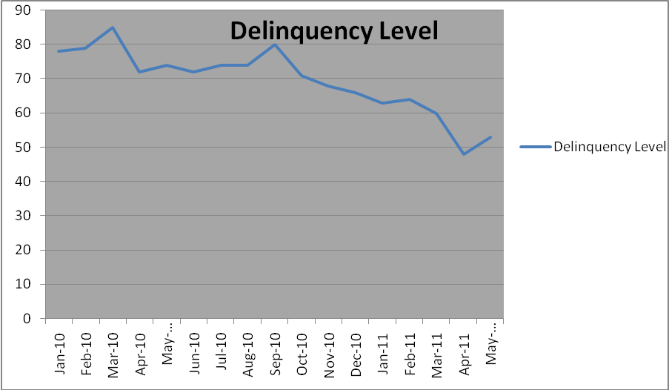

Interpretation
If we look at the trend of OD days of Ludhiana branch of Mahindra finance, then we can easily interpret that the delinquency level was higher in the starting months of the year 2010 which was 78 days in the month of Jan 2010 as compare to the year 2011in which it was only 53 days in the month of May 2011. So we have seen a decreasing trend in the level of Delinquency days in the last year which is a good sign for the branch. It can be said that it is the result of consistent efforts of the management and the collection team of the branch.

For studying the Delinquency level of Ludhiana branch in a refined manner, I have segmented the study in four segments: -
- Sector Wise Delinquency level
- Customer profile Wise Delinquency level
- Dealer wise Delinquency level

7.3 Sector wise delinquency level

This segmentation is done to know that which sector is performing well and which is not in the Ludhiana branch. It will help the branch in taking precautionary measures to reduce the Delinquency level of that sector which is more delinquent as compare to the other, which will ultimately help in increasing the efficiency of the branch.
As on 31st may 2011, the sector wise Delinquency level of Ludhiana branch is as follows:
Table 2: - Sector-Wise Delinquency Level
Sector | No. of HPA | OD | CD | Ratio OD/CD | OD days
Auto | 3288 | 15722800 | 9638840 | 1.63 | 50
Cv_Gen | 76 | 5080333 | 1750026 | 2.90 | 88
Cv_Mah | 21 | 915980 | 262534 | 3.48 | 106
Others | 3787 | 15738291 | 10237856 | 1.53 | 47
Personal loan | 4 | 6510 | 10220 | 0.63 | 19
Tractor | 422 | 1892421 | 1079082 | 1.75 | 53
Tw_Gen | 60 | 369132 | 0 | 0 | 0
Tw_Mah | 108 | 40630 | 192747 | 0.21 | 6

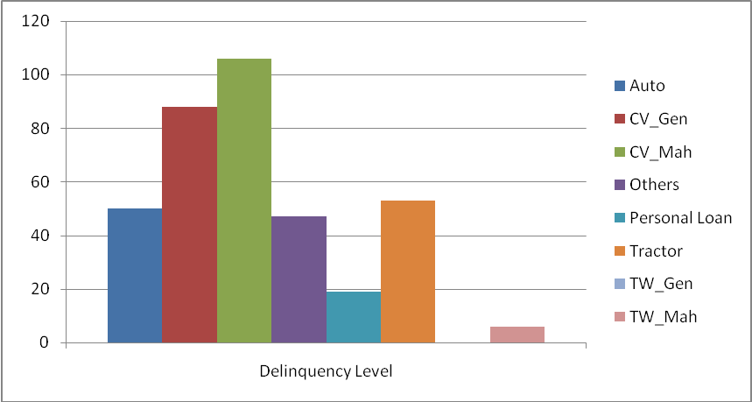

Interpretation
From the above table and charts, we can easily interpret that the CV_Mah sector is the most delinquent sector among all the sectors because it is having the maximum number of delinquency day’s i.e.106 instead of having a very less number of HPA’s. The CV_Gen sector is also very delinquent, where by the sector of TW_Gen is performing very well because it is having zero delinquency days and also the TW_Mah sector is having a delinquency level of 6 days only. So, the steps should be taken to improve the collection efficiency of CV sector.

7.4 Customer profile wise delinquency level
To study the Delinquency level among the different customer profile, I have made this segmentation. It will make the things more clear to the sales executives of Mahindra finance about the repaying trend of people of different customer profiles. And accordingly he can take his decisions in the future about granting the loan, keeping in mind the repaying habits of each category of customer. To study that, I have taken a sample of 150 cases, out of which 75 are from business class and 42 are from salaried class, 13 are agriculturists and 20 are owner cum driver.
Customer Profile | No. Of HPA | OD | CD | Ratio OD/CD | OD days
Owner cum driver | 20 | 96901 | 133864 | 0.72 | 22
Agriculture | 13 | 13300 | 114330 | 0.11 | 3
Salaried | 42 | 73006 | 318166 | 0.22 | 7
businessman | 75 | 159675 | 589514 | 0.27 | 8

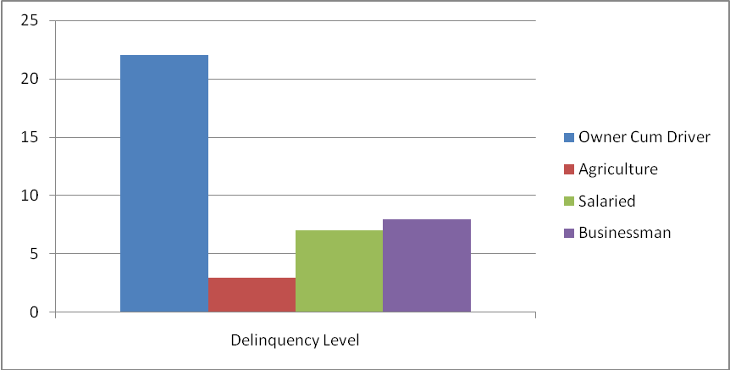

Interpretation
It can easily be interpreted from the table and the graph that the customer having salaried, business and agriculture profile have good repaying behavior because their delinquency level is very low instead of having large number of HPA’s but the repaying behavior of owner cum driver is not good as their delinquency level is high instead of having less number of HPA’s. So, care should be taken in the cases of owner cum driver.
7.5 Dealer wise delinquency level
As on 31st may 2011, the Dealer Wise Delinquency Level is as follows:
Table 3: - Dealer-Wise Delinquency Level
Dealer Name | No. of HPA’s | OD | CD | Ratio OD/CD | OD days
Padam motors | 57 | 42506 | 402031 | 0.10 | 3
Kohli auto company Khanna-CV | 18 | 889270 | 262534 | 3.38 | 103
Libra auto car company ltd. | 397 | 1351433 | 1845596 | .732 | 22
Dada motors pvt.ltd | 8 | -64 | 155404 | 0 | 0
Balak automobiles Pvt ltd.-LOGAN | 28 | 523624 | 288724 | 1.81 | 55
Balak automobiles Pvt. ltd-AD | 78 | 616199 | 987828 | 0.623 | 19
India motors | 22 | 30576 | 146566 | .208 | 6
Kissan auto sales | 5 | -342100 | 19680 | 0 | 0
Shiv motors Eicher | 31 | 2729 | 836297 | .003 | 0
Omni wheels Pvt. Ltd | 11 | 17600 | 136090 | .129 | 4
Gulzar motors Pvt. Ltd | 38 | 14280 | 262925 | .054 | 2
Dada motors Nissan | 10 | 0 | 120255 | 0 | 0
Dada motors Pvt. ltd-TATA | 9 | -10 | 80870 | 0 | 0
Agro sales & tractors Pvt. ltd. | 81 | 627712 | 192639 | 3.25 | 99
Balak auto Pvt. Ltd | 373 | 2343954 | 1791101 | 1.30 | 40
Garyson motors Pvt. Ltd | 76 | 695562 | 401201 | 1.73 | 53
Godawari motors Pvt. ltd. | 26 | 18875 | 2809020 | .006 | 0
Gulzar motors ltd-Ludhiana | 248 | 1407415 | 980862 | 1.43 | 44
Kohli auto company Khanna-AD | 1523 | 5190428 | 4087308 | 1.26 | 39
Modern motors | 1027 | 4332291 | 1896580 | 2.28 | 70
Refinance | 575 | 1987850 | 489752 | 4.05 | 123
Stan autos Pvt. Ltd | 938 | 2615105 | 2158707 | 1.21 | 37
Sandhu automobiles Pvt. Ltd | 248 | 1220542 | 898723 | 1.35 | 41
Stan wheels Pvt. ltd. | 121 | 611686 | 810955 | .754 | 23
Modern motors LOGAN | 59 | 1058655 | 404499 | 2.61 | 80
Mela Singh and sons | 81 | 36375 | 141507 | .257 | 8
Shiv Om motors | 23 | 4255 | 43792 | .097 | 3
Suresh tractors and spares | 16 | -8409 | 139087 | 0 | 0
Swani motors Pvt. ltd. | 75 | 887447 | 184388 | 4.81 | 146
Kissan tractors and automobiles | 30 | 285873 | 239740 | 1.19 | 36

Interpretation:
In the above table, the dealer wise delinquency level of the dealers of MMFSL-Ludhiana branch is shown, from this we can interpret that the delinquency days of Kohli Auto Company Khanna- CV sector is very high which is 103 days, instead of having very less number of HPA’s with them i.e. only 18.
On the other hand, the number of HPA’s of Kohli Auto Company Khanna- AD sector is very high i.e. 1523, but still they have very low delinquency level i.e. 39. So, it shows that AD sector is doing well, but care should be taken to reduce the delinquency level of CV sector.
Moreover, the efforts should be made to reduce the delinquency days of modern motors as they are having large contracts with MMFSL. i.e.1027.
Also, the OD days of Swani motors Pvt. ltd. And of Refinance cases is very high i.e. 146 and 123 days respectively, which is a matter of concern for the company.
Currently, Ludhiana branch is doing business with a very large number of dealers whose Delinquency level varies to a large extent.
7.6 Reasons of default:
There are many reasons due to which the customer defaults in making his payment on the due date.
Majorly the defaulters are of 2 types:
- Intentional defaulters
- Situational defaulters
Intentional defaulters: the defaulters who have enough money to make the payment of their EMI but they intentionally don’t do it are called the intentional defaulters. The payment or nonpayment of the applicant does not depend on his paying capacity but on the intentions and willingness of the applicant to pay the installment.
Situational defaulters: the defaulters who make defaults in the payment due to some unavoidable circumstances are called situational defaulters. The situation in front of them is as such that they want to make payment but they don’t have enough amount at that point of time to make the payment. So, they make default. The situational factors depend on the financial capacity of the applicant to pay the amount.
Some of the reasons of Situational defaults are as follows:
(1)Loss in the business: The customer becomes unable to pay the installment on due date if he faces any kind of loss in the business.
(2)Vehicle out of order/damaged: When the source of earning of the customer is the vehicle only and if that vehicle got out of order then it becomes difficult for the applicant to pay the installment on due date and he makes a default.
(3)Seasonal factors: If the applicant is an agriculturist or the farmer and his income depends on the growth of the crops, and due to some natural calamities like floods or drought, his crops gets damaged .then he becomes unable to make the payment on time.
(4)Unemployment: If the applicant loses his job, which was the only source of income for him, then it becomes difficult for him to make the arrangement of the money to pay the installment
(5)Health problems: Sometimes due to some health problems, the applicant falls ill and have to make huge expense on his treatment which led to the shortage of funds with him, due to which he do not make payment on due date.
(6)Family disputes: This is also one of the reasons of default by the customer, when the vehicle is taken on the joint name of two persons and the disputes occur between them, then the party makes a default in the payment of their installment.
(7)Accident/death of the applicant: If the applicant met with an accident or he dies then it will also leads to the nonpayment of installments.
(8) Poor credit appraisal: The main reason of increasing number of defaults and delinquency level is the wrong or poor credit appraisal done by the business executive or the credit team. Because they do not consider some of the important factors which needs to be kept in mind while taking decision about the creditworthiness of the customer.

7.7 Factors Affecting Delinquency Level
There are different factors which influence the repaying habit of the applicant. These factors can be divided into 3 categories like:
- Financial factors- There are different financial factors which influence the repaying habits of the person. The factors like salary of applicant, income source, stock of the business, sales turnover of the business, profits, debt equity ratio, and liquidity ratios comes under this category.
- Operational factors- The operational may include the following things like fleet size of the transporter, size of order, number of rounds, viability etc.
- Situational factors- There are some situational factors also which influence the repaying habits of the individual like the standard of living, reference check, matching of product with the asset demanded.

After discussing this topic with the business and collection executives, I have come to know that there are many more factors also which influence the repaying habits of the applicant. These are as follows:
- Age
- Financial strength
- Family credentials
- Qualification
- Nature of business or profession
- Mode of payment
- Experience
- Tenure of loan
- Assets already owned and their financing patterns
- Present and expected liabilities
- Finance amount
- Ability and intension of applicant
- Need of vehicle
- Saving and investment habits of applicant
To find out the effect of these factors on the repaying habits and Delinquency level of the branch, I have taken a sample of 150 cases, and applied the various statistical tools to find out whether there is any correlation or significance difference between the various factors considered and the Delinquency level of the customers.
The demographic factors taken are as follows:
- Age
- Occupation
- Income
- Qualification
- Gender
And some other factors considered are as follows:
- Purpose
- Marital status
- Mode of payment
- Tenure of loan
- Finance amount

7.8 Hypotheses
H1_{a}.There is significant association between age and delinquency level.
H2_{a.} There is significant association between occupation and delinquency level.
H3_{a}.There is significant association between income and delinquency level.
H4_{a.}There is significant association between qualification and delinquency level.
H5_{a}. There is significant association between gender and delinquency level.
H6_{a}. There is significant association between purpose of taking vehicle and delinquency level.
H7_{a}.There is significant association between marital status of applicant and delinquency level.
H8_{a}.There is significant association between mode of payment and delinquency level.
H9_{a.} There is significant association between tenure of loan and delinquency level.
H10_{a.} There is significant association between finance amount and delinquency level.

7.9 Research Design or Data presentation
Out of the sample of 150 files, the frequencies of different factors considered are as shown below in the form of Frequency table and also in the form of Pie charts to make the study more understandable:
Occupation:

Occupation of the customer
 |  | Frequency | Percent | Valid Percent | Cumulative Percent
Valid | Businessman | 76 | 50.7 | 50.7 | 50.7
Valid | Salaried | 41 | 27.3 | 27.3 | 78.0
Valid | Agriculturist | 13 | 8.7 | 8.7 | 86.7
Valid | Owner cum driver | 20 | 13.3 | 13.3 | 100.0
Valid | Total | 150 | 100.0 | 100.0

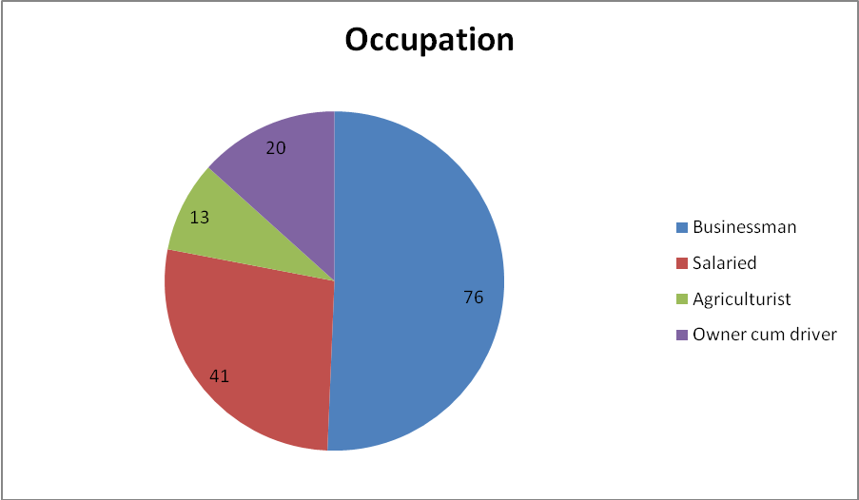

Qualification:

Qualification of the customer
 |  | Frequency | Percent | Valid Percent | Cumulative Percent
Valid | 10th | 53 | 35.3 | 35.3 | 35.3
Valid | 12th | 55 | 36.7 | 36.7 | 72.0
Valid | Graduate | 37 | 24.7 | 24.7 | 96.7
Valid | Post graduate | 5 | 3.3 | 3.3 | 100.0
Valid | Total | 150 | 100.0 | 100.0

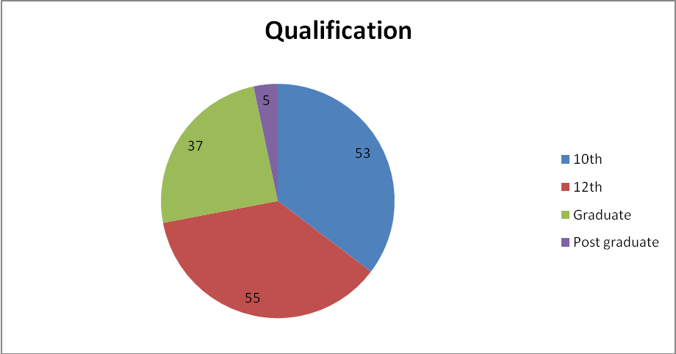
Gender:

Gender of the customer
 |  | Frequency | Percent | Valid Percent | Cumulative Percent
Valid | Male | 134 | 89.3 | 89.3 | 89.3
Valid | Female | 16 | 10.7 | 10.7 | 100.0
Valid | Total | 150 | 100.0 | 100.0

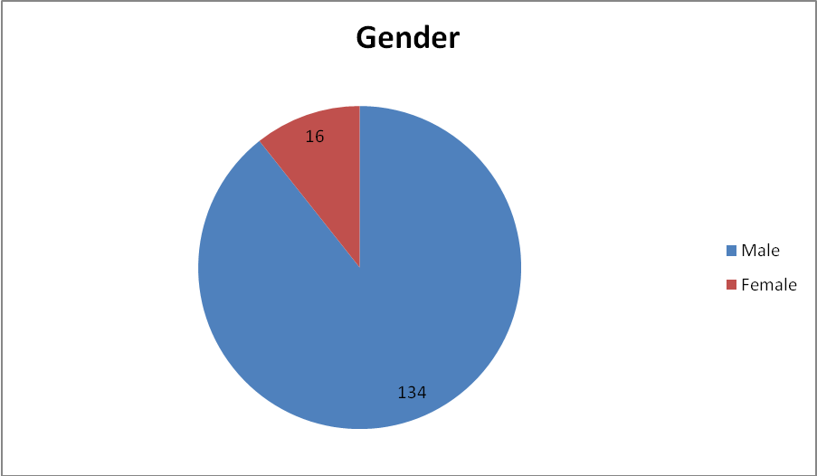
Purpose:

Purpose of taking vehicle
 |  | Frequency | Percent | Valid Percent | Cumulative Percent
Valid | Personal use | 80 | 53.3 | 53.3 | 53.3
Valid | Captive use | 29 | 19.3 | 19.3 | 72.7
Valid | Commercial use | 41 | 27.3 | 27.3 | 100.0
Valid | Total | 150 | 100.0 | 100.0
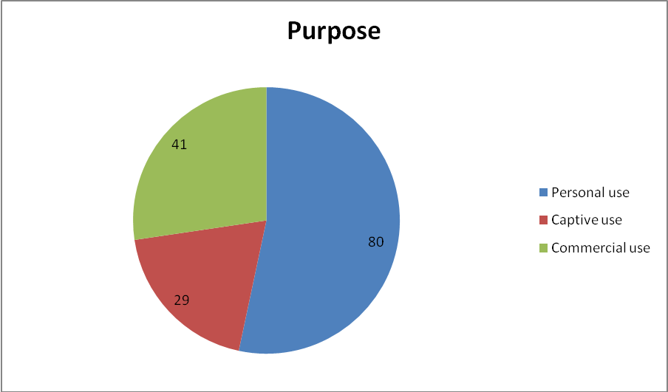

Marital status:

Marital status of the customer
 |  | Frequency | Percent | Valid Percent | Cumulative Percent
Valid | Married | 138 | 92.0 | 92.0 | 92.0
Valid | Unmarried | 12 | 8.0 | 8.0 | 100.0
Valid | Total | 150 | 100.0 | 100.0

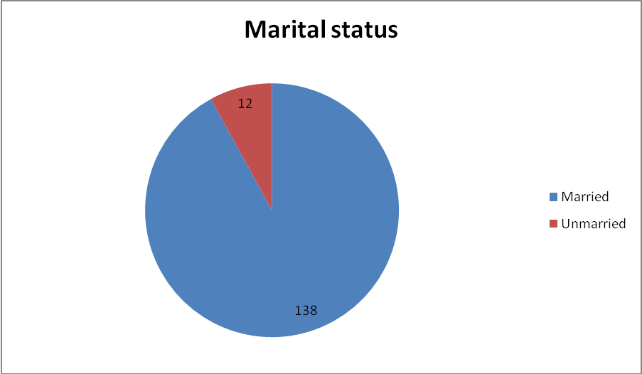

Mode of payment:

Mode of payment by customer
 |  | Frequency | Percent | Valid Percent | Cumulative Percent
Valid | Cash | 62 | 41.3 | 41.3 | 41.3
Valid | PDC | 64 | 42.7 | 42.7 | 84.0
Valid | ECS | 24 | 16.0 | 16.0 | 100.0
Valid | Total | 150 | 100.0 | 100.0

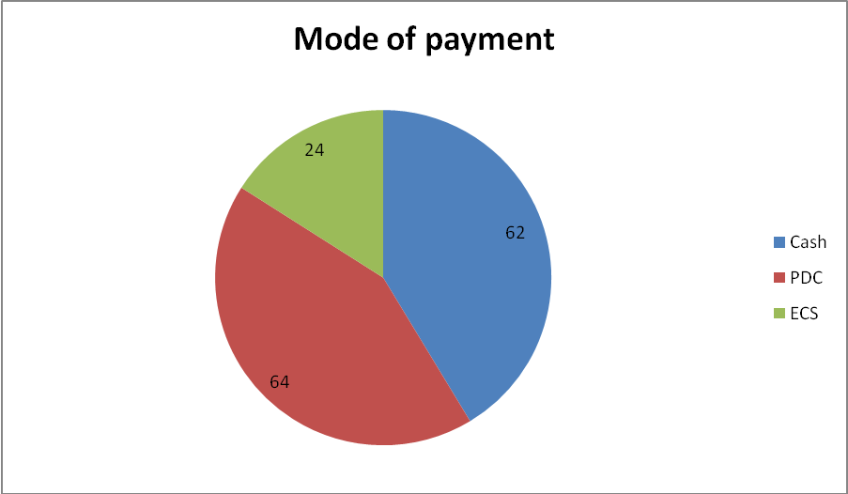
7.10 Data analysis
The data was analyzed using SPSS. Necessary tables encompassing SPSS output is included in the article at the appropriate places. The confidence level of 95 % is assumed for the study.
To test the hypotheses, different test are used as shown below:
(1) For 1st hypothesis: Bivariate Correlation is used
Table for age and delinquency level is shown below:

Correlations
 |  | Age of the customer | Delinquency Level
Age of the customer | Pearson Correlation | 1 | -.070
Age of the customer | Sig. (2-tailed) |  | .396
Age of the customer | N | 150 | 149
Delinquency Level | Pearson Correlation | -.070 | 1
Delinquency Level | Sig. (2-tailed) | .396
Delinquency Level | N | 149 | 149

The results of correlation suggested no significant association between age and delinquency level. Since the p-value is more than .05(p equals .396).therefore first null hypothesis that there is no significant association between age and delinquency level is not rejected or may be accepted.
(2) For 2nd hypothesis: One-Way ANOVA is used.
Table for occupation and delinquency level is shown below:

ANOVA
Delinquency Level
 | Sum of Squares | Df | Mean Square | F | Sig.
Between Groups | 3165.960 | 3 | 1055.320 | 1.515 | .213
Within Groups | 101030.132 | 145 | 696.760
Total | 104196.092 | 148

The results of one-way ANOVA suggested no significant association between occupation and delinquency level. Since the p-value is more than .05(p equals .213).therefore second null hypothesis that there is no significant association between occupation and delinquency level is not rejected or may be accepted.

(3) For 3rd hypothesis: Bivariate correlation is used.
Table for income and delinquency level is shown below:

Correlations
 |  | Delinquency Level | Income of the customer
Delinquency Level | Pearson Correlation | 1 | .045
Delinquency Level | Sig. (2-tailed) |  | .584
Delinquency Level | N | 149 | 149
Income of the customer | Pearson Correlation | .045 | 1
Income of the customer | Sig. (2-tailed) | .584
Income of the customer | N | 149 | 150

The results of correlation suggested no significant association between income and delinquency level. Since the p-value is more than .05(p equals .584).therefore third null hypothesis that there is no significant association between income and delinquency level is not rejected or may be accepted.

(4) For 4th hypothesis: one-way ANOVA is used.
Table for qualification and delinquency level is shown below:

ANOVA
Delinquency Level
 | Sum of Squares | Df | Mean Square | F | Sig.
Between Groups | 475.678 | 3 | 158.559 | .222 | .881
Within Groups | 103720.413 | 145 | 715.313
Total | 104196.092 | 148

The results of one-way ANOVA suggested no significant association between qualification and delinquency level. Since the p-value is more than .05(p equals .881).therefore forth null hypothesis that there is no significant association between qualification and delinquency level is not rejected or may be accepted.
(5) For 5th hypothesis: Independent Samples t-test is used.
Table for gender and delinquency level is shown below:

Independent Samples Test,
 |  | Levene's Test for Equality of Variances |  | t-test for Equality of Means
 |  | F | Sig. | t | Df | Sig. (2-tailed) | Mean Difference | Std. Error Difference | 95% Confidence Interval of the Difference
 |  |  |  |  |  |  |  |  | Lower | Upper
Delinquency Level | Equal variances assumed | .045 | .832 | .362 | 147 | .718 | 2.54784 | 7.04176 | -11.36831 | 16.46400
Delinquency Level | Equal variances not assumed |  |  | .362 | 18.798 | .721 | 2.54784 | 7.03969 | -12.19712 | 17.29281

In this case, the sig value of ‘f’ is .832 which is more than the p value .05, so it shows no significant association, which means, we will take the case where equal variances are assumed, and in that case the ‘p’ value is .718 which is more than .05.So, the results of Independent Samples t-test suggested no significant association between gender and delinquency level, getting p value more than .05(p equals .718).therefore fifth null hypothesis that there is no significant association between gender and delinquency level is not rejected or may be accepted.

(6) For 6th hypothesis: one-way ANOVA is used.
Table for purpose and delinquency level is shown below:

ANOVA
Delinquency Level
 | Sum of Squares | Df | Mean Square | F | Sig.
Between Groups | 1441.004 | 2 | 720.502 | 1.024 | .362
Within Groups | 102755.088 | 146 | 703.802
Total | 104196.092 | 148

The results of one-way ANOVA suggested no significant association between purpose and delinquency level. Since the p-value is more than .05(p equals .362).therefore sixth null hypothesis that there is no significant association between purpose and delinquency level is not rejected or may be accepted.
(7) For 7th hypothesis: Independent Samples t-test is used.
Table for marital status and delinquency level is shown below:
Independent Samples Test
 |  | Levene's Test for Equality of Variances |  | t-test for Equality of Means
 |  | F | Sig. | T | Df | Sig. (2-tailed) | Mean Difference | Std. Error Difference | 95% Confidence Interval of the Difference
 |  |  |  |  |  |  |  |  | Lower | Upper
Delinquency Level | Equal variances assumed | 6.826 | .010 | .884 | 147 | .378 | 7.06330 | 7.99391 | -8.73452 | 22.86113
Delinquency Level | Equal variances not assumed |  |  | 2.043 | 35.837 | .048 | 7.06330 | 3.45660 | .05188 | 14.07473

In this case, the sig value of ‘f’ is .010 which is less than the p value .05, so it shows significant association ,which means, we will take the case where equal variances are not assumed , and in that case the ‘p’ value is .048 which is less than .05 , So, the results of Independent Samples t-test suggested significant association between marital status and delinquency level, getting p value less than .05(p equals .048).therefore seventh null hypothesis that there is no significant association between marital status and delinquency level is rejected.

(8) For 8th hypothesis: one-way ANOVA is used.
Table for mode of payment and delinquency level is shown below:

ANOVA
Delinquency Level
 | Sum of Squares | Df | Mean Square | F | Sig.
Between Groups | 4543.023 | 2 | 2271.511 | 3.328 | .039
Within Groups | 99653.069 | 146 | 682.555
Total | 104196.092 | 148

The results of one-way ANOVA suggested significant association between mode of payment and delinquency level. Since the p-value is more than .05(p equals .039).therefore eight null hypothesis that there is no significant association between mode of payment and delinquency level is rejected.
(9) For 9th hypothesis: Bivariate Correlation is used
Table for tenure of loan and delinquency level is shown below:
Correlations
 |  | Delinquency Level | tenure of loan
Delinquency Level | Pearson Correlation | 1 | .111
Delinquency Level | Sig. (2-tailed) |  | .176
Delinquency Level | N | 149 | 149
tenure of loan | Pearson Correlation | .111 | 1
tenure of loan | Sig. (2-tailed) | .176
tenure of loan | N | 149 | 150

The results of correlation suggested no significant association between tenure of loan and delinquency level. Since the p-value is more than .05(p equals .176).therefore first null hypothesis that there is no significant association between tenure of loan and delinquency level is not rejected or may be accepted.
(10) For 10th hypothesis: Bivariate Correlation is used
Table for finance amount and delinquency level is shown below:
Correlations
 |  | Delinquency Level | finance amount
Delinquency Level | Pearson Correlation | 1 | .092
Delinquency Level | Sig. (2-tailed) |  | .264
Delinquency Level | N | 149 | 149
finance amount | Pearson Correlation | .092 | 1
finance amount | Sig. (2-tailed) | .264
finance amount | N | 149 | 150

The results of correlation suggested no significant association between finance amount and delinquency level. Since the p-value is more than .05(p equals .264).therefore first null hypothesis that there is no significant association between finance amount and delinquency level is not rejected or may be accepted.

CHAPTER – 4
CONCLUSION AND RECOMMENDATIONS

8.1 Findings and Conclusions
- No significant association was found between age and delinquency level.

- No significant association was found between occupation and delinquency level.

- No significant association was found between income and delinquency level.

- No significant association was found between qualification and delinquency level.

- No significant association was found between gender and delinquency level.

- No significant association was found between purpose and delinquency level.

- A significant association was found between marital status and delinquency level.

- A significant association was found between mode of payment and delinquency level.

- No significant association was found between tenure of loan and delinquency level.

- No significant association was found between finance amount and delinquency level.
8.2 RECOMMENDATIONS FOR REDUCING DEFAULTS
As we have seen that the OD days of Ludhiana branch are very high in many of the sectors, and it is a matter of concern for the branch, so, steps should be taken to reduce the increasing level of delinquency and the number of defaults. Some of the steps which should be taken are discussed as below:
- PROPER CREDIT APPRAISAL SHOULD BE DONE: The business executive and the credit team of the company should do the credit appraisal of the applicant properly and should also consider the following factors which affect the default rate as we have proved.
- As the significant association was found between the marital status and the delinquency level, so this factor should be given priority while doing the credit appraisal of the applicant.

- We have also seen that there is significant association between the mode of payment and the delinquency level, so the credit manager should consider this factor as important while doing the credit appraisal of the applicant.
- TIMELY REMINDERS TO THE DEBTORS
The debt holders should be reminded to pay the dues in a timely manner. The customer must be reminded of his dues by SMSs, e-mails or phone calls in short intervals.
- REGULAR FOLLOW UP WITH THE CUSTOMERS
Regular follow up of the cases must be done by the collection executives. Personal visits to the OD customers need to be increased as well.
- ONLINE PAYMENT OPTION
For the customers who have the net banking facility; online payment option should be encouraged. This will be convenient for the customers to make the in time payment online through the website of Mahindra Finance. The customers can also check their account online.
- EDUCATION TO THE CUSTOMER ABOUT SECTION 138
The customer should be made aware of the section 138 which gives right to the company to file a case against the customer in case of the bouncing of the cheque.

Section 138: Dishonor of cheque for insufficiency, etc., of funds in the accounts under Negotiable Instruments, Act
Where any cheque drawn by a person on an account maintained by him with a banker for payment of any amount of money to another person from out of that account for the discharge, in whole or in part, of any debt or other liability, is returned by the bank unpaid, either because of the amount of money standing to the credit of that account is insufficient to honor the cheque or that it exceeds the amount arranged to be paid from that account by an agreement made with that bank, such person shall be deemed to have committed an offence and shall without prejudice to any other provisions of this Act, be punished with imprisonment for two years or with fine which may extend to twice the amount of the cheque, or with both. Provided that nothing contained in this section shall apply unless-
(a) The cheque has been presented to the bank within a period of six months from the date on which it is drawn or within the period of its validity, whichever is earlier.
(b) The payee or the holder induce course of the cheque, as the case may be, makes a demand for the payment of the said amount of money by giving a notice, in writing, to the drawer, of the cheque, ["within thirty days"] of the receipt of information by him from the bank regarding the return of the cheques as unpaid, and
(c) The drawer of such cheque fails to make the payment of the said amount of money to the payee or, as the case may be, to the holder in due course of the cheque, within fifteen days of the receipt of the said notice.
- EDUCATION TO THE CUSTOMER REGARDING CIBIL

The customer who pays EMIs irregularly should be educated that his poor track record will be reflected in the CIBIL which is a certified agency. Every finance company checks the CIBIL record of the customer before giving finance to the prospective customer. Therefore the customer should be intimidated about the consequences of non-payment of EMIs.

- SHOULD FOLLOW THE DEDUPE CHECK:
Dedupe is the most important part of every financial institution, it is used to check the credit status of customer who has applied for a Loan. Lender checks the details of previous loans taken by customers with own institution & also with other financial institution through dedupe check (De-Dupe-Duplication entry of Name, Address, Birth Date, PAN Card, etc.,) Dedupe check of particular customer is done on internal data (SAS) & External Data (CIBIL).If the customer is defaulter, his dedupe is 'Bad Match', if customer has made repayment of previous loan without default, his dedupe is 'Good Match'. If no loan taken till now then it is 'No Match' .Loan is rejected to Customer with Bad Match.

- FRAUD AND RISK CONTROL UNIT:
Mahindra and Mahindra financial services limited should take a help of fraud and risk control units. PAMAC has recently introduced services of skip tracing, claim investigation, and employment background check for all its clients. PAMAC utilizes its vast database and local field level expertise to get the latest contact details of customer, which help clients in their collection activities.

BIBLIOGRAPHY
- “Business Research Methods”, seventh edition, by William G. Zikmund, Cengage Learning Publication.

- “Financial Planning – A ready reckonor”, by Madhu Sinha, Tata Mc Graw Hill Publication

- N.Muthukumaran, ICICI bank ltd. (2010) “A study on effectiveness of capital appraisal system for working capital loans in icici bank at Chennai” available at http://www.scribd.com/doc/25918660/A-Study-on-Effectiveness-of-Credit-Appraisal-System-for-Working-Capital-Loans-in-ICICI-Bank-at-Ch?in_collection=3147707

- Kamdica, union bank of India (2009), “Union bank credit appraisal project report” available at http://www.scribd.com/doc/21042504/Union-Bank-credit-appraisal-project-report

- Sayan Chatterjee, ING Vysya bank (2010),”Project study on credit appraisal of ING Vysya bank” available at http://www.oppapers.com/essays/Credit-Appraisal/646043

- Mathew Joseph, HDFC Bank (2007),”Loan origination and appraisal techniques” available at http://www.auhf.co.za/training/MATHEW%20JOSEPH_Loan%20Origination_Appraisal%20Techniques_%20HDFC.pdf

- Refer to http://www.oppapers.com/essays/Credit-Appraisal/646043

- Refer to http://www.scribd.com/doc/60199254/44337444-Credit-Evaluation

- www.moneycontrol.com

- www.wikipedia.org

